Little SPARK: Simple Play Adaptations to Reference for Kids

GoTalk One
Description: | Image:
The GoTalk One is a single message, Augmentative and Alternative Communication (AAC) device that supports communication throughout daily activities. | 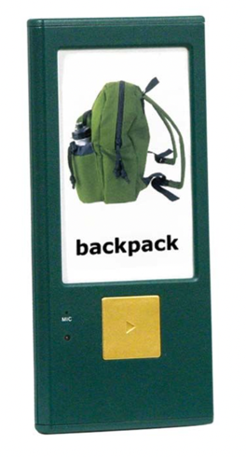

Who Might Benefit?
Those who have difficulty understanding oral instructions, talking/communicating with others, completing multi-step activities.
Why Use?
Provides an opportunity to make choices, comment to others, view a visual and auditory cue as many times as needed to support schedules, routines, activities, and instruction.
Instructions for Use: | Adaptation Ideas:
Environmental Considerations  - Use in any environment and on the go, avoid using in unusually loud spaces.  Positioning & Alternate Positioning  - Use in any position or attach to any surface.  Basic Play/Use  - Place a picture symbol in the frame, record, and press play using the front button.  Extended Play/Use  - Use for any of the following: instruction, requests, participation, information sharing, communication, games, classroom management, or self-care skills. | Build It Up  - Velcro a plastic bottle cap to the button to build up the surface.  Stabilize It  - Velcro to most surfaces or place Dycem/cabinet liner under the switch.  Add Sensory Cues  - Add textures or change the button color.  Alternative Uses  - Use with multiple GoTalk Ones to create a choice board, steps in an activity, first/then support, or sequencing a simple sentence.

